24 September 2024 postcard

Great day today!

We had to get an early start—luggage outside by 6:45 am, load the buses by 7:45 am—to get it all in.

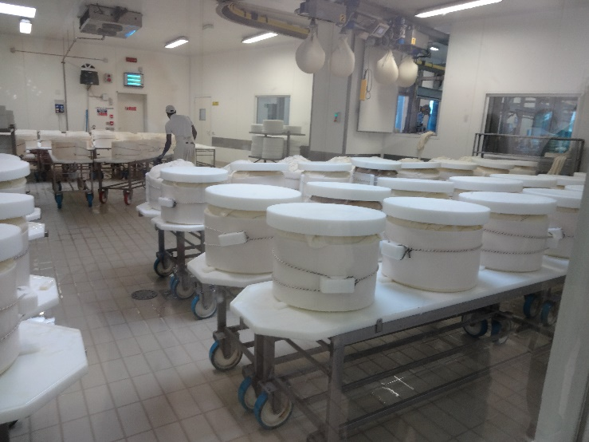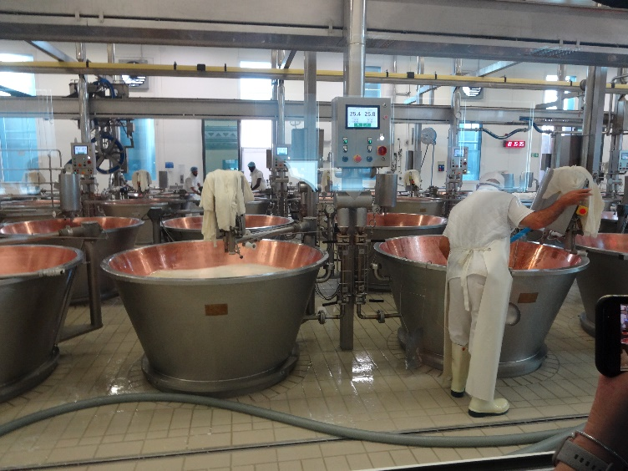We shuttled from our hotel back to our bus in the fleet of minivans, then set off for a tour of a Parmesan cheese factory. We've toured a number of cheese factories, but never one for that kind of hard *pâte cuite croute lavée* style of cheese. Our visit was timed so that we got to watch the day's batch of curd being hauled out of the copper-lined kettles in big cheesecloth bundles, plopped into large cylindrical molds, and topped with 25 lb weights to begin the compression and drainage phase.

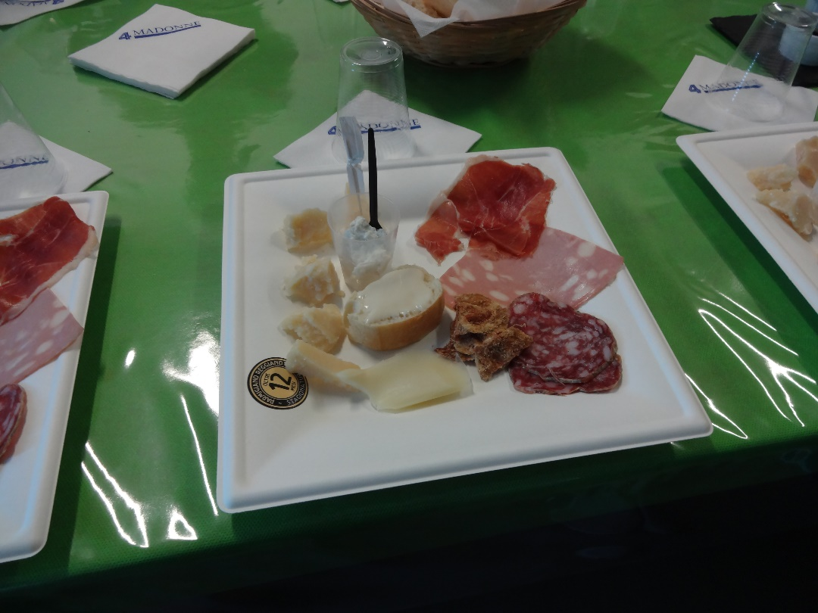

The tour was excellent and informative and ended with this tasting, which featured Parmesan made from Holstein milk and aged 12, 24, 36, and 48 months as well as one made from the milk of red cows and aged 24 months. Plus ricotta, bread spread with melted cheese, cheese made from the trimming of slightly oversized Parmesan wheels, prosciutto, mortadella, and odd crispy "cookies" of pork cracklings. Also pumpkin mostarda, plum jam, and balsamic vinegar.

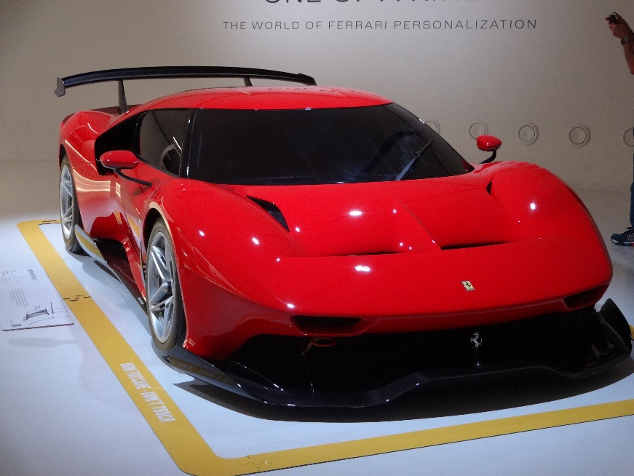Then back into the buses for a tour of the Ferrari museum in Modena. Car after flashy car, including this custom-made one-off for a client in Hong Kong, strictly for track use—it's not street legal, since it has no headlights.

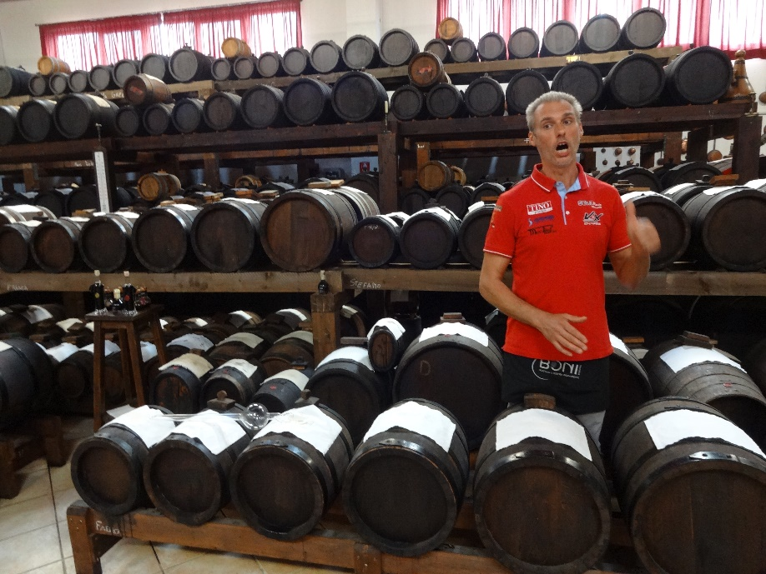

Then back into the bus again for the short trip to a balsamic-vinegar producer! This maker's total annual production is only 24 to 28 gallons a year of very good and very expensive vinegar. But he supplements his income by selling "cooked" grape juice to locals who use it to make their own. Not a simple process, since it takes 12 years to produce the first batch.

That tour ended with a tasting even more elaborate than the last.

Finally, after a little time at the hotel (which included a tour by an art historian of some of the features of the incredibly historic building we're staying in), we headed to a restaurant a couple of blocks away for a great Italian dinner.